**Connectivity diagram on STM32cubeIDE**

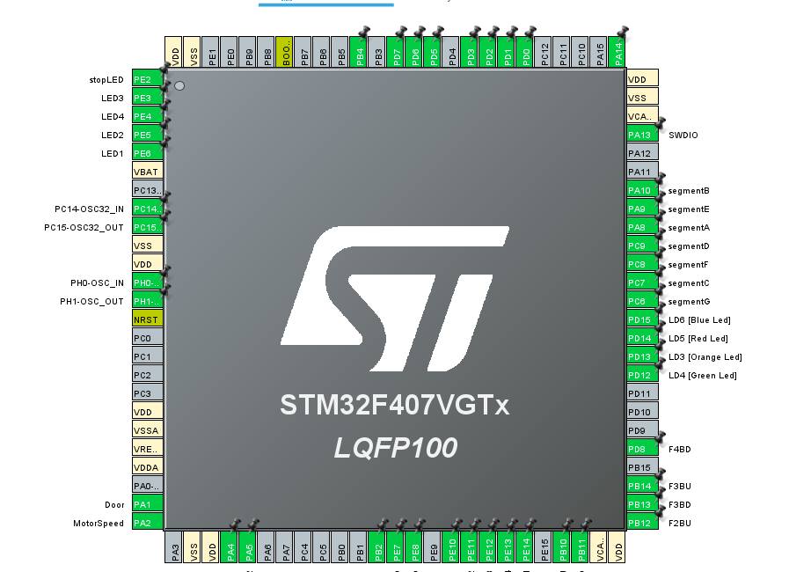

**Connections:**

**•** PA4, PA5: Motor driver IN1 and IN2 connections (used as PWM mode)

• PE7, PE8: Up and down LED (green) (used as output)

• PE10-PE14: Floor buttons (BTN1-BTN4) & emergency button (used as interrupts)

• PB10, PB11, PB12-PB14, PD8: Floor up-down indication buttons (used as timer interrupts)

• PC6-PC9, PA8-PA10: 7-segment display pins (used as output)

• PE3-PE6: Floor LEDs (yellow) (used as output)

• PE2: stop LED/door open indicator (red) (used as output)

• PD0-PD3, PD5-PD7, PB4: IR sensors (used as interrupts)